THIS IS A PRACTICE ASSESSMENT. Show formulas, substitutions, answers, and units!

Topic A.2.3 Circular motion
A 6.5-kg bowling ball is being swung horizontally in a clockwise direction (as viewed from above) at a constant speed in a circle of radius 1.5 m.
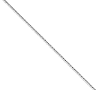
1. Suppose the time it takes the ball to make one complete revolution is 4.0 s. What is the centripetal acceleration of the ball?
2. What is the tension in the cable that is used to swing the ball?
3. What is the distance the ball travels in one revolution?
4. What is the work done by the tension in one revolution?
5. What is the angular speed of the ball?
6. What is the angular velocity of the ball?

A 6.5-kg bowling ball is being swung horizontally in a counterclockwise direction (as viewed from above) at a constant speed in a circle of radius 1.5 m.

7. Suppose the speed of the ball is 8.0 ms⁻¹. What is the centripetal acceleration of the ball?
8. What is the period of the ball?
9. What is the frequency of the ball?
10. What is the angular velocity of the ball?
11. What is the work done by the tension in the cable used to swing the ball during one revolution?

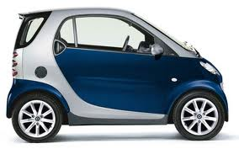
A 725-kg car is traveling north and makes a gradual turn to the east at a constant speed of 25.0 ms⁻¹. The radius of the turn is 128 m.
12. What is the angular velocity of the car during the turn?

13. What friction force is needed for this turn?
14. What is the smallest radius for which the turn could be designed so that the car does not slip at this speed. Assume the coefficient of static friction is 0.750 and that the road is level (unbanked).

15. What is the purpose of banking roads?
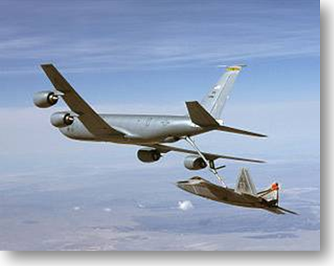

A loaded KC-135 Stratotanker air refueling plane has a loaded mass of 135000 kg. It is shown traveling north at a speed of 853 km h⁻¹ and banking at an angle of θ = 24˚ in level flight.
16. How does a plane bank?
17. Label the vectors, WEIGHT, LIFT, and CENTRIPETAL FORCE, in the diagram.
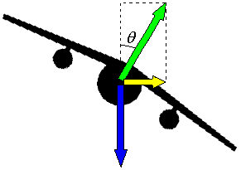
18. Find the magnitude of the weight vector.
19. Find the magnitude of the vertical component of the lift vector.
20. Find the magnitude of the horizontal component of the lift vector.
21. What is the centripetal acceleration of the plane?
22. What is the radius of the turn?
23. How long will it take for the plane to travel to the east if it maintains its speed?

The Goliath is a new wooden roller coaster that allows the riders to go upside-down on the loop shown below. The starting height of the coaster is 125. m. The radius of the loop is 25.0 m. Riders board the cars at A. The 2300-kg car is drawn by a chain up to the point B and then released from rest. Gravity does everything from then on through the points C, D and E!

A

B

C

D

E

24. What is the kinetic energy of the car at D?
25. What is the speed of the car at D?
26. What is the magnitude of the normal force between car and track at D? Include a free-body diagram of the car at D.
27. What is the maximum radius that the loop could have so that the car does not lose contact with the track at D?

D.1 Gravitational fields (SL)
28. State Newton’s universal law of gravitation.
29. Explain Newton’s shell theorem and why it is useful for finding the gravitational force between, say, a planet and a moon.
30. A planet has a mass of M = 7.5×10²⁶ kg and its moon has a mass of m = 2.2×10²¹ kg. The mean distance between the planet’s center and its moon’s center is 1.4×10⁹ m. What is the gravitational force between them?
31. Define gravitational field strength.
32. Explain why the concept of field replaced the concept of action-at-a-distance.

Three regions in the vicinity of the earth are shown below at different scales.

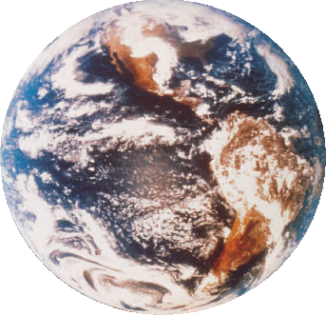
Earth Surface of Earth Ice rink
33. Sketch the gravitational field lines near each object:
34. Which of the above gravitational fields is uniform and constant? How can you tell?

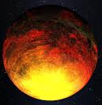
A planet has a mass of 2.50×10²⁸ kg and a radius of 8.75×10⁶ m. It has an angular speed of 0.0000625 rad s⁻¹.
35. What is the gravitational field strength 8.75×10⁸ m from the center of this planet?
36. What is the acceleration of a 25.0-kg mass dropped at this point?
37. If we wanted that same mass to be in orbit at this radius, what velocity would this mass have to have?
38. What would its period be?
39. What is the value of g at the surface of this planet?
40. If a 25.0-kg mass is dropped near the surface of this planet, what would its acceleration be?
41. What would its weight be?
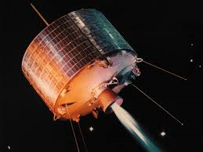
42. What is the length of a day, in hours, for this planet?
43. How many planet radii would a geosynchronous satellite need to be placed?

Two masses of 4.50×10²² kg each are located along the x-axis. The first mass is at the origin, and the second mass is at x = ⁺1.25×10⁶ m.
44. Find the gravitational field strength at the point on the x-axis directly between the two masses.
45. Find the gravitational field strength at x = ⁺2.50×10⁶ m.
46. If a 16.5-kg mass is released at x = ⁺2.50×10⁶ m, what will its acceleration be (both magnitude and direction).
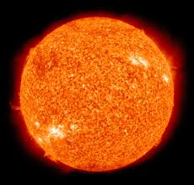
The sun has a mass of 1.989×10³⁰ kg.
47. Given that an earth year is 365.25 d, find the radius of the earth orbit (assuming it is circular).
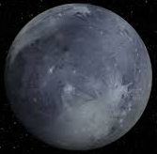
48. Given that the speed of light is c = 3.00×10⁸ ms⁻¹, find out how long it takes light from the sun to reach earth. Convert your answer to minutes.
49. Given that a Pluto year is 90471 Earth days, what is Pluto’s orbital radius?

50. How long does it take light from the sun to reach Pluto?
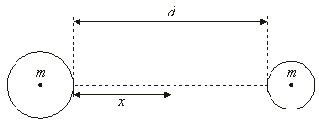
Two isolated spheres of equal mass and different radii are held a distance d apart. The gravitational field strength is measured on the line joining the two masses at position x which varies.
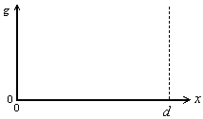
51. Graph the variation of g with x.
52. Why is g less on one side than on the other even though the masses are the same?

53. Why is g = 0 somewhere between the two masses?

